ITCS 1010 Programming Logic

Logic Plan 5 – Chapter 5 – 20 points

“Distance Calculator using Loop Logic”

Student Name ________Steven Woodard_________

Given the following problem statements, perform the steps and answer the questions listed below, which are designed to help you analyze the problem and prepare a strategy for solving the problem. Submit this logic plan and C# Project into a folder, zip the folder, and submit in Blackboard for grading.

Problem statement: Create an application that lets the user enter the Vehicle Speed in MPH and Hours Traveled in input text boxes. When the user clicks the Calculate button, the application should use a LOOP to display in an output list box the distance the vehicle has traveled for each hour of that time period. See textbook page 347, under Programming Problems, the Distance Calculator for guidance.

For example: Distance = (Speed x Time)

Vehicle Speed in MPH: 40
Hours Traveled: 3

This program should then display in an output list box, the distance traveled after each hour as a detail line, for example:

After hour 1 the distance is 40
After hour 2 the distance is 80
After hour 3 the distance is 120

Also, include an Exit button so the user can close the form, a ToolTip on the Calculate and Exit buttons, and include your student name and a proper title in the title bar of the form.

Use label controls, button controls, and program comments where applicable. Make sure the C# program is free of syntax and logic errors.

Create a file folder on your USB Port drive or hard drive at home, and call it “Logic Plan5 Your student name”. For example “Logic Plan5 DLohn”.

There is no VideoNote associated with this Lab.

Before coding the program, create the Logic Plan! Design the Program’s Logic: enter your answers in the IPO chart below. Write pseudocode and insert below. Draw a flowchart and insert below.
(Hint: reference the Tutorial 5-1 and Tutorial 5-3 Logic Plan found in this Tutorial!)

What must the user enter as INPUT?
INPUT
Speed in MPH, and time traveled in hours

Example:
Int mph = 60
Int hours = 2

How will the program calculate the distance traveled?
PROCESSING
For each hour, Speed is multiplied by that hour
Store distance traveled in that hour’s designated line

For each hour
hoursDistanceTraveled = Hour X mph

What OUTPUT will the program display?
OUTPUT
Each line for each hour is published

Example:
Line 1 => hour 1 => 60 mph
Line 2 => hour 2 => 120 mph

ENTER PSEUDOCODE HERE the pseudocode you wrote below in this Word document for grading.

//USER CLICKS ON CALCULATE BUTTON
//DECLARE VARIABLES
//FOR EACH HOUR
//MULTIPLY EACH HOUR BY THE SPEED AND PUSH TO LINE
//DISPLAY TO USER

//USER CLICKS ON EXIT BUTTON
//PROGRAM CLOSES

DRAW OR COPY/PASTE FLOWCHART HERE the flowchart you designed below in this Word document for grading:

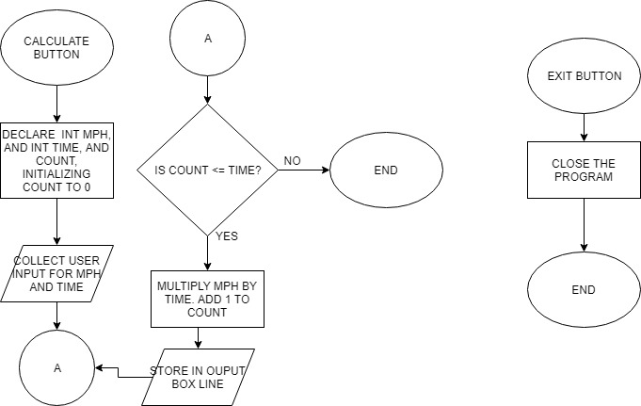

Save this project in your “Logic Plan 5 your student name” file folder and submit in this category for grading.

